ECE 387 Group Project Written Proposal

Project title: Automatic cleaning robot

Team Members: Yifan Wang, Yifan Fang, Haixu Dong, Qi Yu

**Project Description and Goal**

When practicing in the gym, people are tired grabbing the towels to clean the equipment everytime after each movement. To change its condition, we decided to make a robot which help to sweep the seat in the gym. The robot will randomly searching around the room and detect the certain type of equipment then clean it. It will be avoid to make collision with people as they will walking through the hallway. As the equipments are in different shapes, we decided to choose to clean the flat weight bench and adjustable weight bench which is shown in figure 1. The final goal is to let the robot sweep the used benches without hitting people and other equipment. The microchip will be used is arduino.

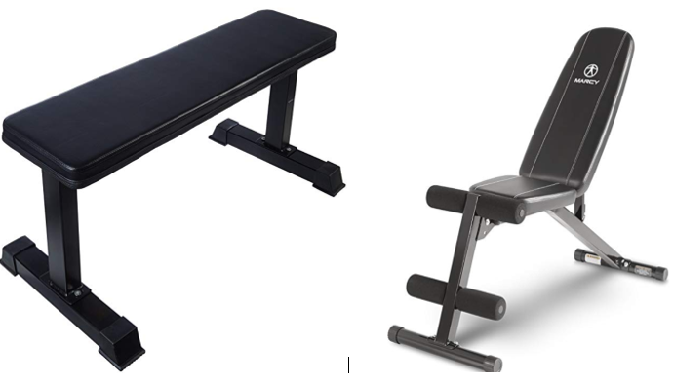Figure1. Flat weight bench and adjustable weight bench.

**Possible features:**

The robot will possibly runs as a little car carrying with a infrared sensor and a ultrasonic sensor which is shown by figure 2. The little car will be round shape to make it easier to turn into any side. To achieve the sweep function, a robot arm will be used and set on the moving base which is shown by figure 3.

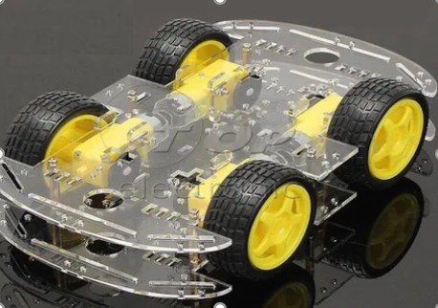

Figure 2. Possible shape of the moving base.

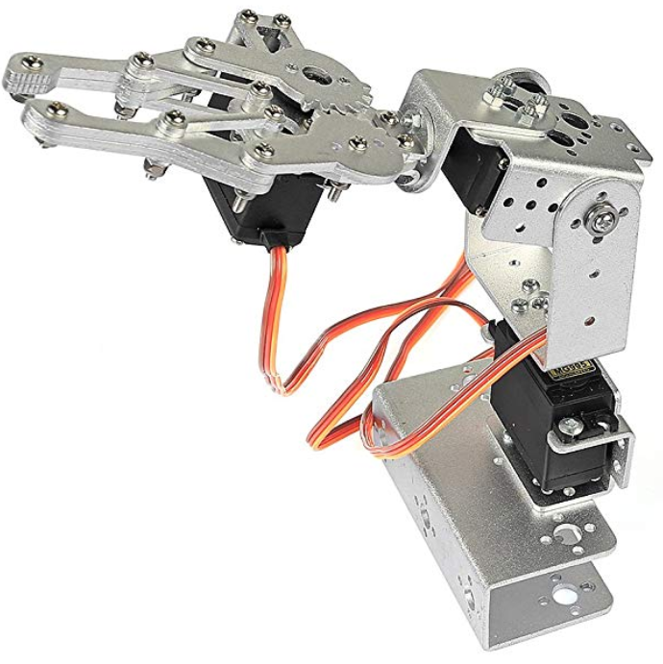

Figure 3. Possible shape of the robot arm.

**Method:**

The moving base will act as a robot car which will run based on the arduino microprocessor. To achieve not touch any people and anything including the wall and the equipments, we will use the infrared sensor and ultrasonic sensor together to detect the circumstance around the car. Giving the sensor a distance, when the sensor sense there are something in the moving way, the car will turn to another direction and keep moving. The ultrasonic sensor will help the car being able to avoid obstacles and the infrared detector will help the car being able to detect an infrared light and go toward that light. Finally add a robot arm to the robot to make our robot perform the act of “sweeping seat”. To make sure the robot arm can find the right equipment, we will put a infrared emitter on one end of the bench. Then, the robot arm will track the location of the infrared emitter. When the robot reach the location of the infrared emitter, the robot will begin to sweep from the point of the infrared emitter. In other words, the emitter will be the start point of the cleaning process.

Note: May have alternative method due to developing process. Estimate cost is around $120. 20 for infrared part. $50 for robot arm, and $50 for Arduino car.

**Expectation:**

We choose a specific type of bench in gym and put an infrared emitter to the seat. Then we put our robot with some distance from that seat. Once the robot is turned on, it will detect the location of infrared light and move toward it. If robot meet obstacles on its way, turn to another path and detect the location of infrared light again and go toward it. Once it reach the seat, turn on the robot arm and perform sweeping action.

**preliminary plan on what needs to be done:**

By(03/12/2019): Finish buying all the parts

By (03/20/2019): finish the code of the car and test the function of the car

By(04/01/2019): finish the code of the robot arm and test the movement of the robot arm

By(04/10/2019): Put the robot arm on the car and finish the whole code

By(04/20/2019): finish the report

**preliminary plan on task distribution:**

**Yu:** Responsible for purchasing product and coding process of the car

**Dong:** Responsible for coding of the robot arm

**Fang:**Responsible for assembling individual parts together

**Wang:** Responsible for testing results and debugging the robot